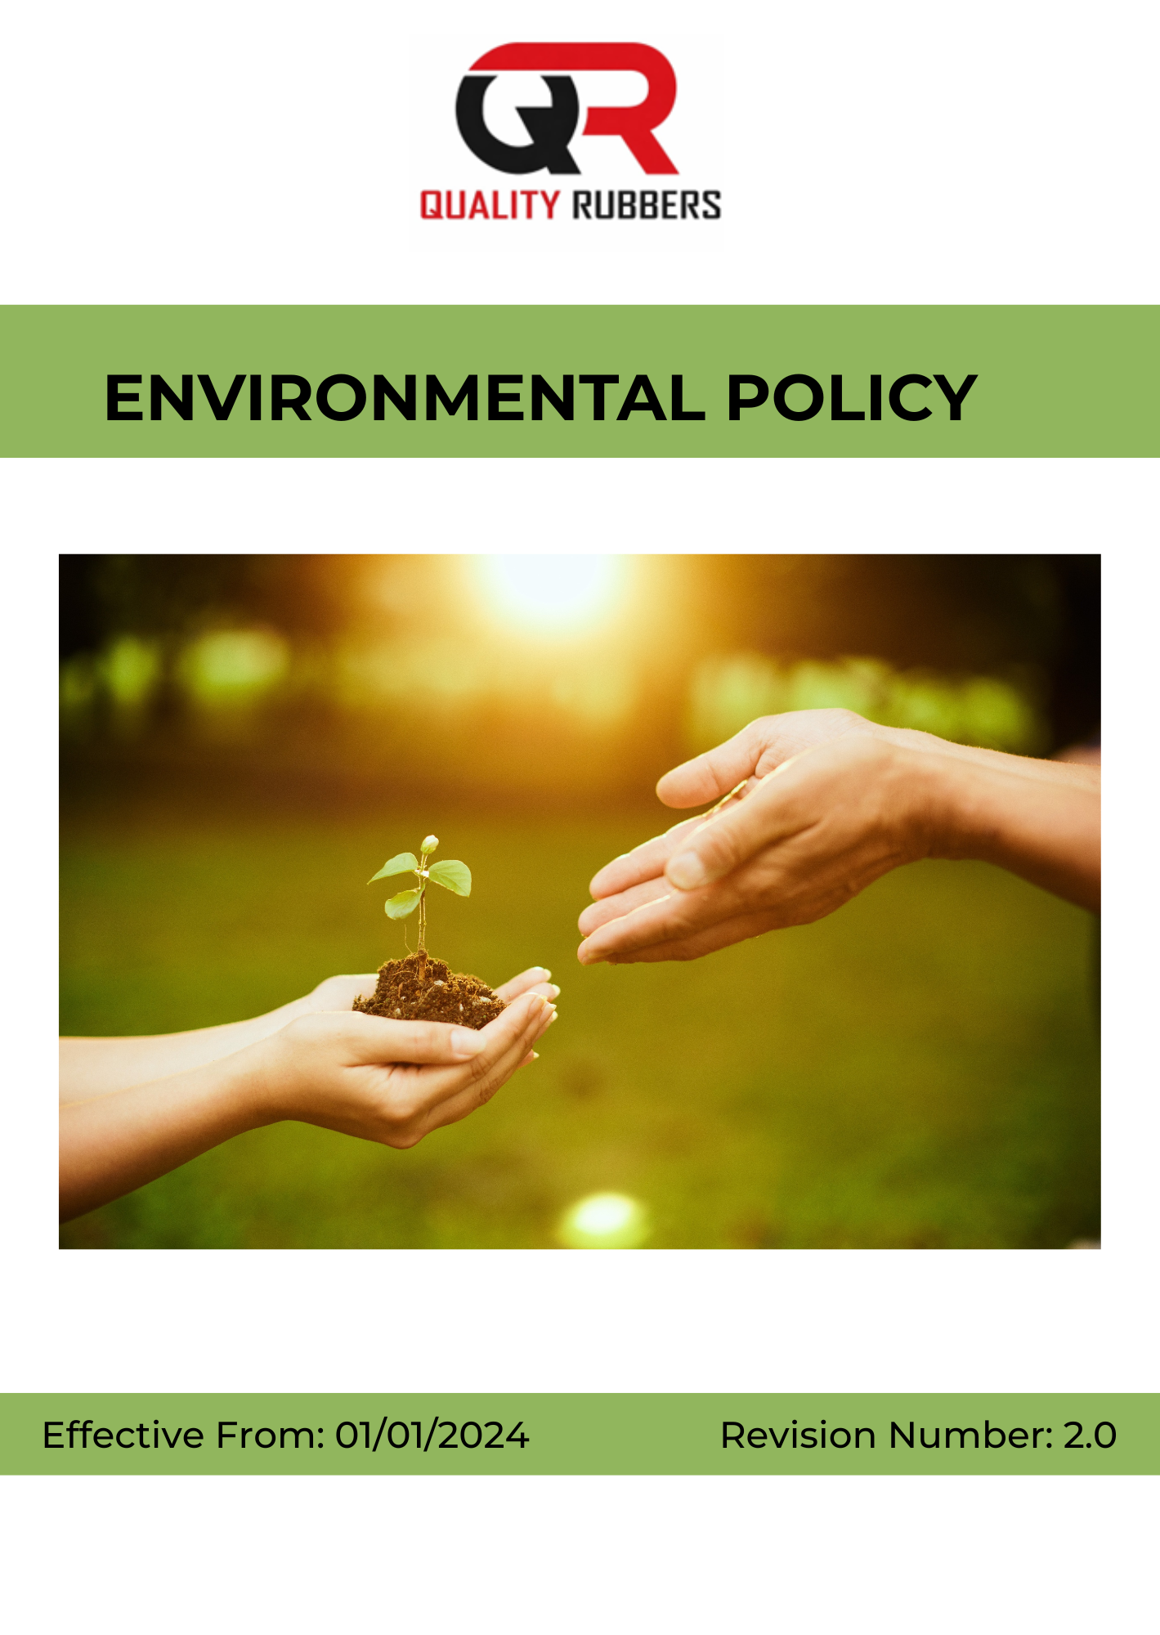

INDEX
1. Policy Intent 3
2. Scope of the Policy 3
3. Key Environmental Priorities for Sustainability at Quality Rubbers 3
4. Quality Rubbers Sustainability Commitments and Performance Areas 4
5. Organizational Responsibilities for Environmental Management at Quality Rubbers 8
6. Tracking and Monitoring Environmental Performance at Quality Rubbers 10
7. Performance Enhancement and Continuous Improvement at Quality Rubbers 10
8. Policy Review and Update Mechanism 11
9. Employee Acknowledgement 12

Policy Intent
At Quality Rubbers, we are committed to environmental responsibility and sustainable operations. We recognize that rubber processing activities including material handling, energy consumption, waste generation, and transportation can have an impact on the environment. Accordingly, we strive to minimize these impacts through responsible practices, efficient resource utilization, and continuous improvement.

We believe that integrating sustainability into our operations is essential for long-term business success as well as environmental protection. This policy reflects our commitment to reducing environmental impact, optimizing the use of natural resources, and promoting responsible processing and logistics practices.

By embedding environmental considerations into all aspects of our operations from material handling and processing to transportation and waste management Quality Rubbers aims to operate responsibly and contribute towards a more sustainable future.

Scope of the Policy
This policy applies to all employees, workers, directors, officers, contractors, and any third parties acting on behalf of Quality Rubbers. It covers all business activities associated with the Company’s operations, including sourcing of raw rubber materials, cleaning and upgrading processes, storage, handling, transportation, and dispatch of materials, as well as interactions with customers, suppliers, regulatory authorities, and other stakeholders.

Quality Rubbers | 10/587, Azhiyannur Post, Kadampazhipuram, Palakkad, Kerala, 678633, India.

Key Environmental Priorities for Sustainability at Quality Rubbers
Quality Rubbers recognizes the environmental impacts associated with raw material sourcing, energy-intensive processing, emissions, and waste generation. To address these challenges and align with sustainable practices, the following key environmental priorities have been identified:

- We aim to promote responsible sourcing of natural and synthetic rubber by encouraging procurement from certified suppliers, ensuring traceability, and supporting practices that help prevent deforestation and biodiversity loss.
- We aim to improve energy efficiency by monitoring energy consumption, optimizing processes, enhancing equipment efficiency, and adopting energy-saving and renewable energy solutions wherever feasible.
- We aim to measure and reduce greenhouse gas emissions (Scope 1 and Scope 2) through cleaner fuels, operational improvements, and promotion of low-carbon initiatives.
- We aim to control air emissions by using appropriate pollution control systems, monitoring key pollutants such as particulate matter and VOCs, and ensuring regulatory compliance.
- We aim to strengthen water stewardship by promoting efficient use, reuse and recycling of water, and ensuring proper treatment of wastewater before discharge.
- We aim to minimize waste generation by improving process efficiency, promoting recycling and reuse of materials, and ensuring safe disposal of hazardous and non-hazardous waste.
- We aim to ensure safe chemical management through proper storage, labeling, handling practices, and reduction of hazardous substances wherever alternatives exist.
- We aim to support biodiversity protection by avoiding sourcing from ecologically sensitive areas and encouraging conservation practices across stakeholders.
- We aim to ensure environmental compliance through adherence to applicable laws, monitoring of environmental performance, and internal audits.
- We aim to promote environmental awareness and engagement by encouraging employee participation, supporting community initiatives, and strengthening sustainability communication.

Quality Rubbers Sustainability Commitments and Performance Areas

1. Sustainable Raw Material Sourcing

Focus Area | Target Description | Metric / Measurement | Baseline Year | Target
Certified Sourcing | Increase procurement from certified sustainable rubber sources | % of certified raw material procurement | 2023 | 8% increase by 2030
Deforestation-Free Sourcing | Ensure sourcing avoids deforestation and biodiversity loss | % deforestation-free sourcing | 2023 | 100% by 2030
Supplier ESG Compliance | Improve environmental compliance among suppliers | % suppliers assessed on ESG criteria | 2023 | 6% increase by 2030
Responsible Procurement Coverage | Expand sustainability criteria in procurement process | % procurement under ESG screening | 2023 | 8% increase by 2030

2. Energy Consumption and Efficiency

Focus Area | Target Description | Metric / Measurement | Baseline Year | Target
Energy Reduction | Reduce overall energy consumption in operations | % reduction in total energy use | 2023 | 7% reduction by 2030
Equipment Efficiency | Improve efficiency of machinery and utilities | % efficiency improvement | 2023 | 6% improvement by 2030
Process Optimization | Reduce energy losses in operations | % reduction in energy losses | 2023 | 5% reduction by 2030
Energy Monitoring | Ensure full energy monitoring across facilities | % facility coverage | 2023 | 100% by 2030
Renewable Energy Use | Increase use of renewable energy sources | % renewable energy share | 2023 | 8% increase by 2030

3. Greenhouse Gas (GHG) Emissions Reduction

Focus Area | Target Description | Metric / Measurement | Baseline Year | Target
Absolute Emissions Reduction | Reduce total Scope 1 & 2 emissions | % reduction in tCO₂e | 2023 | 7% reduction by 2030
Absolute Emissions Reduction | Reduce total Scope 3 emissions | % reduction in tCO₂e | 2023 | 10% reduction by 2035
GHG Intensity Reduction | Reduce greenhouse gas emissions intensity through energy efficiency, cleaner fuels, and operational improvements | % reduction in GHG intensity (Scope 1 + Scope 2) (Metric tonnes of CO2 equivalent/ INR million) | 2023 | 6% reduction by 2030
Fuel Efficiency | Reduce fossil fuel consumption in operations | % reduction in fuel use | 2023 | 6% reduction by 2030
Emissions Monitoring | Strengthen GHG tracking system | % emissions sources monitored | 2023 | 100% by 2030

4. Air Emissions Management

Focus Area | Target Description | Metric / Measurement | Baseline Year | Target
Emission Control Systems | Install air pollution control systems | % system coverage | 2023 | 100% by 2030
Particulate Reduction | Reduce particulate matter emissions | % reduction in PM | 2023 | 6% reduction by 2030
VOC Reduction | Reduce VOC emissions from operations | % reduction in VOCs | 2023 | 7% reduction by 2030
Regulatory Compliance | Ensure regulatory compliance | % compliance | 2023 | 100% annually through 2030

5. Water Stewardship and Wastewater Management

Focus Area | Target Description | Metric / Measurement | Baseline Year | Target
Water Reduction | Reduce freshwater consumption | % reduction in water use | 2023 | 6% reduction by 2030
Water Recycling | Increase wastewater reuse | % reuse rate | 2023 | 8% increase by 2030
Wastewater Treatment | Treat all wastewater before discharge | % wastewater treated | 2023 | 100% by 2030
Contamination Prevention | Prevent water pollution incidents | Number of incidents | 2023 | Maintain 0 incidents through 2030
Water Monitoring | Strengthen water monitoring systems | % facility coverage | 2023 | 100% by 2030

6. Waste Reduction and Circular Economy

Focus Area | Target Description | Metric / Measurement | Baseline Year | Target
Waste Reduction | Reduce total waste generation | % reduction in waste | 2023 | 7% by 2030
Recycling Rate | Increase waste recycling and reuse | % recycling rate | 2023 | 8% by 2030
Hazardous Waste Reduction | Reduce hazardous waste generation | % reduction | 2023 | 6% by 2030
Waste Segregation | Ensure full waste segregation | % compliance | 2023 | 100% by 2030

7. Biodiversity and Land Use Protection

Focus Area | Target Description | Metric / Measurement | Baseline Year | Target
Deforestation-Free Sourcing | Ensure no sourcing from sensitive ecosystems | % compliance | 2023 | 100% by 2030
Biodiversity Protection | Support biodiversity initiatives | Number of initiatives | 2023 | Nos. of initiatives by 2030
Supplier Awareness | Improve supplier awareness programs | % suppliers trained | 2023 | 7% by 2030
Sustainable Land Use | Promote responsible land use | % compliance | 2023 | 100% by 2030

8. Compliance and Environmental Governance

Focus Area | Target Description | Metric / Measurement | Baseline Year | Target
Regulatory Compliance | Ensure full legal compliance | % compliance | 2023 | 100% annually through 2030
Environmental Audits | Conduct regular audits | Number of audits | 2023 | 7% increase by 2030
Monitoring Systems | Improve monitoring coverage | % coverage | 2023 | 100% by 2030

9. Environmental Engagement & Advocacy

Focus Area | Target Description | Metric / Measurement | Baseline Year | Target
Employee Engagement | Promote sustainability awareness and responsible practices among employees | % of employees participating in sustainability programs | 2023 | 100% by 2030
Training & Awareness | Conduct structured environmental training programs for employees | Number of training sessions per year | 2023 | ≥6 per year through 2030
Community Initiatives | Support environmental awareness and conservation programs in local communities | Number of initiatives conducted per year | 2023 | ≥4 per year through 2030.
Industry Participation | Participate in industry forums, certifications, and sustainability initiatives | Number of participations per year | 2023 | ≥3 per year through 2030

Organizational Responsibilities for Environmental Management at Quality Rubbers
- Senior Management
- Strategic Direction: Provide leadership and ensure alignment of environmental initiatives with business strategy and sustainability commitments.
- Resource Allocation: Ensure adequate financial, technical, and human resources are available for environmental programs.
- Stakeholder Engagement: Engage with regulatory bodies, industry associations, and external stakeholders on environmental matters.
- Risk Oversight: Review environmental risks and ensure appropriate mitigation and control measures are implemented.
- Environmental Officer
- Policy Implementation: Oversee implementation, monitoring, and periodic review of the Environmental Policy.
- Program Management: Drive initiatives related to energy efficiency, water conservation, waste management, and emissions control.
- Regulatory Compliance: Ensure compliance with applicable environmental laws, standards, and internal procedures.
- Training & Awareness: Organize training programs to promote environmental awareness and responsible practices.
- Performance Monitoring: Track environmental KPIs and report progress to senior management.
- Sustainability and Compliance Officer
- Audit & Inspection: Conduct regular environmental audits and compliance checks.
- Incident Management: Investigate environmental incidents and ensure corrective and preventive actions are implemented.
- Documentation & Reporting: Maintain records, monitoring systems, and environmental reporting frameworks.
- Continuous Improvement: Recommend improvements to policies and procedures based on audits and regulatory updates.
- External Coordination: Liaise with auditors, consultants, and regulatory authorities.
- Functional and Operations Management
- Operational Controls: Implement controls to minimize emissions, waste generation, and resource consumption.
- Resource Efficiency: Ensure efficient use of energy, water, and raw materials in daily operations.
- Waste Handling: Ensure proper segregation, storage, recycling, and disposal of waste.
- Emergency Response: Maintain preparedness for environmental incidents such as spills, leaks, or contamination.
- Monitoring & Escalation: Report environmental risks and incidents for timely corrective action.
- Employee Representatives
- Feedback Mechanism: Gather and communicate employee feedback on environmental practices.
- Awareness Promotion: Support awareness of sustainability initiatives across the workforce.
- Program Participation: Encourage and participate in environmental programs and campaigns.
- Communication Link: Act as a bridge between employees and management on environmental matters.
- Engagement Support: Promote employee involvement in sustainability initiatives.
- Employees
- Compliance: Adhere to environmental policies, procedures, and guidelines.
- Responsible Use: Use energy, water, and materials efficiently and minimize waste.
- Training Participation: Attend environmental training and awareness programs.
- Incident Reporting: Report environmental risks, incidents, or non-compliance promptly.
- Sustainable Practices: Support environmentally responsible practices in daily work activities.

Tracking and Monitoring Environmental Performance at Quality Rubbers
At Quality Rubbers, monitoring and reporting are integral to ensuring effective environmental management and continuous performance improvement across our operations. We maintain structured processes to track, review, and communicate our environmental performance.
- Performance Tracking: Environmental parameters related to energy consumption, water usage, waste generation, and emissions are regularly monitored against defined performance indicators.
- Periodic Reviews: Environmental data is reviewed at defined intervals to assess progress, identify gaps, and support informed decision-making.
- Internal Audits: Routine internal audits are conducted to evaluate compliance with regulatory requirements and the effectiveness of operational controls.
- Data Integrity and Documentation: Accurate records and documentation systems are maintained to ensure reliability and traceability of environmental data.
- Stakeholder Communication: We engage with employees, customers, regulatory authorities, and local communities to share information, address concerns, and strengthen transparency.
- Performance Disclosure: Environmental performance and key initiatives are communicated through internal reporting systems and external disclosures, where applicable.

Performance Enhancement and Continuous Improvement at Quality Rubbers
At Quality Rubbers, continuous improvement is embedded within our environmental management approach to ensure sustained progress and long-term impact. We regularly review and strengthen our environmental practices to respond to evolving regulatory requirements, operational needs, and sustainability priorities.
- Target Review and Enhancement: Environmental objectives and performance indicators are periodically reviewed and updated to drive measurable improvement.
- Process Optimization: Operational practices are continuously refined to improve resource efficiency, reduce emissions, and minimize waste generation.
- Technology Adoption: We explore and adopt advanced technologies and best practices to enhance environmental performance.
- Training and Awareness: Ongoing training programs are conducted to build employee capability and promote environmental responsibility.
- Stakeholder Integration: Feedback from employees, suppliers, customers, and communities is incorporated to strengthen environmental strategies.
- Innovation and Participation: We encourage innovation and proactive participation across all levels to achieve improved sustainability outcomes.
Through these efforts, Quality Rubbers aims to integrate continuous improvement into its core operations, ensuring that environmental practices remain effective, adaptive, and forward-looking.

Policy Review and Update Mechanism

The Environmental Policy is subject to periodic review to ensure its continued relevance, effectiveness, and alignment with regulatory requirements and organizational objectives.
- The Environmental Officer is responsible for coordinating the review process.
- The policy is reviewed at least once every year or earlier, if required, based on regulatory changes, operational developments, or stakeholder feedback.
- The review process includes assessment of compliance status, progress against environmental performance goals, and identification of improvement opportunities.
- Necessary updates and revisions are implemented to strengthen the policy and ensure alignment with best practices.

Revision History
Revision No. | Date | Description of Change
0.0 | 01/01/2024 | Initial development and release of the Environmental Policy
1.0 | 01/01/2025 | Policy revised to strengthen environmental commitments and align with regulatory requirements
2.0 | 01/01/2026 | Policy revised and updated to include sustainability targets, improved monitoring mechanisms, and enhanced compliance framework

Approved By:
Designation:
Last Review Date: 01/01/2026 Next Review Date: 01/01/2027

Employee Acknowledgement

I hereby acknowledge that I have received, read, and understood the Environmental Policy of Quality Rubbers. I agree to comply with the principles, guidelines, and procedures outlined in this policy and to support the Company’s commitment to environmental protection and sustainable practices.
I understand my responsibility to:

- Follow all applicable environmental policies and procedures.
- Use resources such as energy, water, and materials responsibly.
- Report any environmental risks, incidents, or non-compliance.
- Actively participate in environmental training and awareness programs.

I further acknowledge that adherence to this policy is a condition of my employment and that failure to comply may result in appropriate disciplinary action as per company rules.
I also recognize the importance of continuous compliance and active participation in maintaining high environmental standards. I commit to reporting any environmental risks, incidents, or improvement opportunities to my supervisor or the Environmental Officer and to support ongoing enhancement of environmental practices within the organization.
Employee Details
Name of Employee:
Employee ID:
Designation:
Department:
Date:
Signature:

